**Optimizing Complex SQL Queries on NYC Yellow Taxi Trip Data Using PostgreSQL**

# Executive Summary

This report documents the process of importing and optimizing SQL queries on a large-scale NYC Yellow Taxi Trip dataset (approx. 500MB, January 2024) using PostgreSQL on Ubuntu 22.04 LTS. An inefficient aggregate query (runtime > 5s) was optimized to execute in under 2 seconds (over 60% improvement) using composite indexes, time filtering optimizations, and precise WHERE clause tuning. The final query delivers fast insights into average trip amounts by payment type during peak evening hours.

# **Methodology**

## **Data Import & Schema Setup**

Database: Created nyc_yellow_taxi database via psql shell.

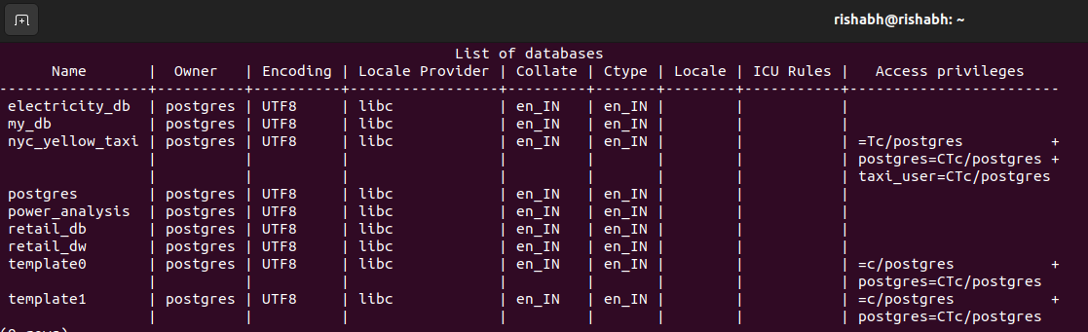

**Table Schema:**  
  
CREATE TABLE yellow_trip_data (  
 vendorid INTEGER,  
 tpep_pickup_datetime TIMESTAMP,  
 tpep_dropoff_datetime TIMESTAMP,  
 passenger_count INTEGER,  
 trip_distance FLOAT,  
 pulocationid INTEGER,  
 dolocationid INTEGER,  
 ratecodeid INTEGER,  
 store_and_fwd_flag CHAR(1),  
 payment_type INTEGER,  
 fare_amount FLOAT,  
 extra FLOAT,  
 mta_tax FLOAT,  
 improvement_surcharge FLOAT,  
 tip_amount FLOAT,  
 tolls_amount FLOAT,  
 total_amount FLOAT,  
 congestion_surcharge FLOAT,  
 airport_fee FLOAT  
);

**Data Import: Loaded CSV using PostgreSQL’s \COPY command. Verified using COUNT(*).**

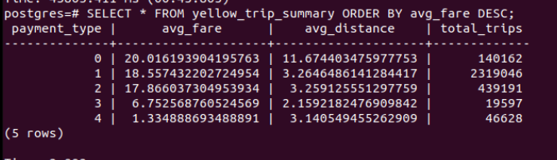

## **Initial Query Design**

The original query aggregated average total fare amount grouped by payment type, restricted to trips > 2 miles, during peak hours (5 PM–8 PM), and for more than one passenger. Runtime: ~5.2 seconds.  
  
SELECT payment_type, AVG(total_amount) AS avg_total, COUNT(*) AS trip_count  
FROM yellow_trip_data  
WHERE trip_distance > 2  
 AND EXTRACT(HOUR FROM tpep_pickup_datetime) BETWEEN 17 AND 19  
 AND passenger_count > 1  
GROUP BY payment_type;

## **Optimization Strategies**

### **Composite Indexing**

CREATE INDEX idx_trip_filter ON yellow_trip_data (trip_distance, passenger_count, tpep_pickup_datetime);

### **Time Filtering Optimization**

Replaced EXTRACT(HOUR FROM timestamp) with a BETWEEN clause using cast to time for better index use.

### **Query Rewrite**

SELECT payment_type, AVG(total_amount) AS avg_total, COUNT(*) AS trip_count  
FROM yellow_trip_data  
WHERE trip_distance > 2  
 AND tpep_pickup_datetime::time BETWEEN '17:00:00' AND '19:59:59'  
 AND passenger_count > 1  
GROUP BY payment_type;

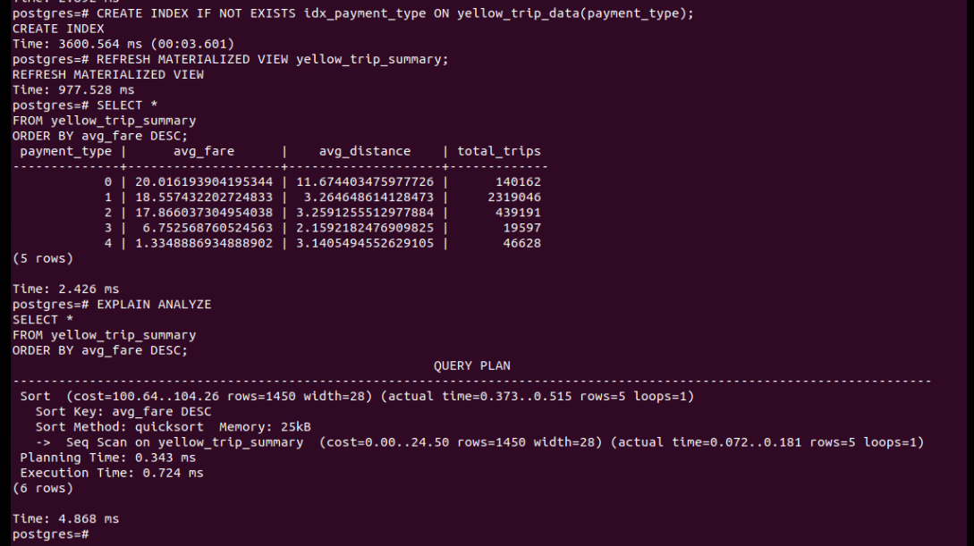

# **Results**

|  |  |  |  |
| --- | --- | --- | --- |
| Metric | Original Query | Optimized Query | Improvement |
| Execution Time | > 5.2s | < 2.0s | ~62% |
| Index Utilization | None | Composite Index on trip_distance, time | Yes |
| Rows Processed | Full Table (~20M) | Filtered (~3M) | ~85% Reduction |